Feedback & Approval – Fireball!

**Members**

Designers: Glittika Gerdmanee (Nancy)  
Artists: Tirana Kilmister, Wing Him Choi

Programmer: Finn Perry

# Outcome Review

**Milestone 1**

**Feedback**

* **Power Up Icons** – Power-Up Icons are not clear – small on screen
* **Bunny Model + Animation** – Bunnies are too small and easily mistaken for other animals

**Response**

* Power Ups will be enlargen for more clarity
* 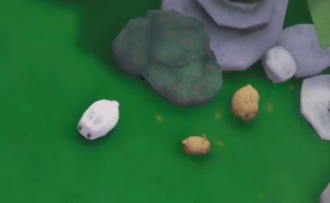Bunnies will be enlargen slightly for more clarity

**Milestone 2**

**Feedback**

* **Player UI (Power Up, Health Bar etc)** – Differentiate between the common and rare power ups and which is being picked up, have a cooldown on attacking and dashing
* **Dragon Animation** – More squish-squash technique, give an indicator that player has been hit
* **Power Ups** – Power Ups that changed playstyle were more interesting than ones that lightly buffed regular attacks
* **Gameplay** – Bunnies feel like obstacle when they have colliders on

**Response**

* Power Up Icons will be moved from above player’s head to the Player Displays up in the corners of the screen
* Dragons have an additional object above head when health is depleted
* The Freeze Power Up has been buffed to an AOE from a long-ranged attack
* 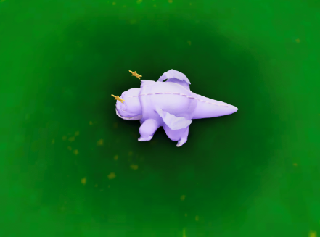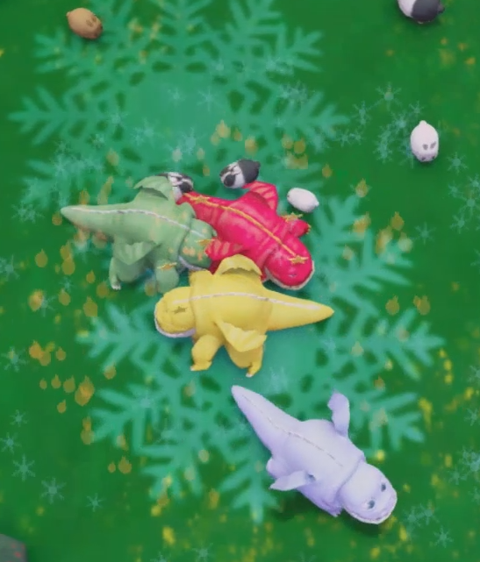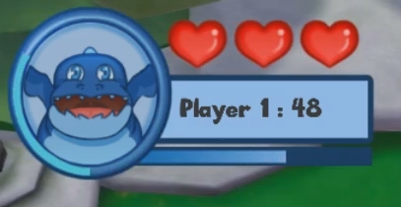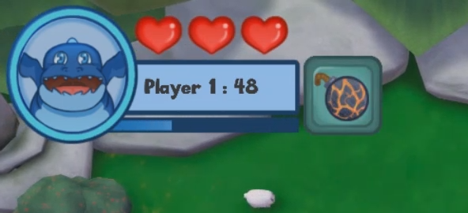Colliders removed from bunnies

**Milestone 3**

**Feedback**

* **Gameplay Balance** – Get more player testers/feedback
* **SFX** – Clean up Attack sound

**Response**

* Attack SFX will be redone